Prerelease Check for tkafg1k.

1. readme document.   
   a. Please replace tab with spaces.   
   b. Remove the spaces in line 108.  
   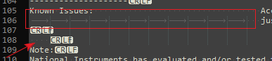
2. Header file: Please swap the definition of these two macros.  
   
3. LV Wrapper:  
   a. Icons for the Vis  
   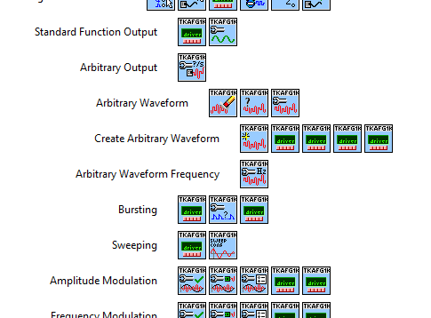  
     
   b. Add examples into the palette  
   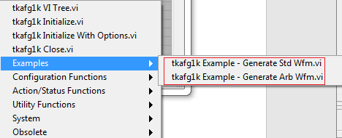
4. Mass compile the wrapper in LV 8.6